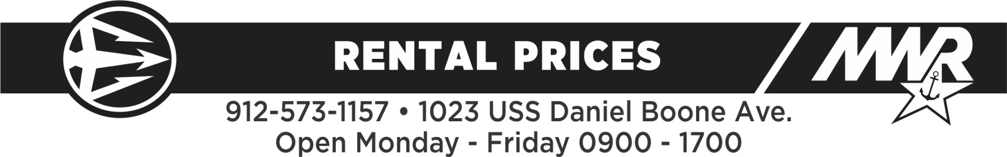

***FEES AND CHARGES***: Military members may reserve equipment up to 45 days in advance. DOD/Civilians may reserve 30 days in advance. In order to reserve, rental items must be paid in full. No refunds on equipment returned prior to check-in date. Failure to comply with proper return policy will result in additional fees.

**C*ANCELLATION POLICY:***  7 or more days in advance - 80% refunded; less than 7 days in advance - 50% refunded.

*\*****NOTE*:** OAC staff are **NOT** responsible for the loading and unloading of rental items.

**SEATING & TABLES**MON-THUR WEEKEND

**MIL CIV**  **MIL CIV**

Folding Chair $1 $1 $1 $1

Padded White Banquet Chair $3 $3 $3 $3

Indoor Black Chair $2 $2 $2 $2

6’ Table $3 $3 $4 $4

8’ Table $4 $4 $5 $5

Round Tables $5 $8 $6 $9

**CANOPIES**  MON-THUR WEEKEND

**MIL CIV**  **MIL CIV**

10’ x 10’ $25 $30 $30 $40

10’ x 20’ $40 $45 $90 $100

**Outdoor Cooking** ($20.00 fee placed on account if returned dirty)

Grill (pull behind 1 7/8” Ball) $30 $35 $50 $55

Smoker w/Box $50 $60 $90 $100

**Coolers** *NO SEAFOOD allowed in coolers

100 Quart $6 $8 $8 $10

**OUTDOOR PAVILIONS Reservation Fee for all of the Pavilions is $25**

***OTTERS COVE at Lake D***

Covered pavilion with picnic tables and grill, running water and electricity, access to restrooms. Sand volleyball courts, Playground, Horseshoe pits

***LAKEVIEW at Lake D***

Covered pavilion with picnic tables and grill, access to restrooms, Playground, Horseshoe pits

***ETOWAH PARK after Trident Lakes Golf Club***

Covered pavilion with picnic tables and grill, Non-drinkable water, access to restrooms, access to fishing dock. $5 per night camping fee.

**LAKE D BOATS** MON-THUR WEEKEND

**MIL**  **CIV MIL CIV**

14’ Jon Boat $8 $12 $12 $15

Boat Package: boat, trolling motor, $24 $34 $34 $39

45lb battery and charger

NOTE: Jon Boat rental includes paddles, an anchor and a lifejacket for each on-board occupant.

**RECREATION EQUIPMENT** MON-THUR WEEKEND

**MIL CIV**  **MIL CIV**

Sit-On-Top Kayak-1 person $15 $20 $30 $35

Sit-On-Top Kayak-2 person $20 $25 $40 $50

Sea Kayak-1 person $20 $25 $40 $50

**CAMPING EQUIPMENT** MON-THUR WEEKEND

**MIL CIV MIL CIV**

Camp Stove $5 $5 $5 $5

2 Person Tent $5 $6 $10 $12

6 Person Tent $7 $8 $14 $16

NOTE: All Tents MUST be returned clean and dry, $20.00 fee charged to account if returned dirty.

**BASE LICENSES**

Base Fishing* $15

Base Hunting* $30

Boat Registration $30

Deals on Wheels $12/week * Must show proof of ownership of vehicle*

Dog Park Registration $5/DOG NON HOUSING RESIDENT HOUSING RESIDENT FREE

*Must obtain Georgia State License first go to [www.georgiawildlife.com](http://www.georgiawildlife.com)

**MWR equipment is for personal use only for the benefit of authorized patrons for recreational purposes. The use of MWR equipment for fund-raising or business purposes is a violation of policy and may result in termination of MWR privileges.**

***Other MWR Outdoor Recreations***

**NAS Jacksonville** - 904-542-3681 **NAVSTA Mayport** - 904-270-5221 **Panama City** - 850-234-4402

**Pensacola** - 850-453-9435/3798 or 850-452-2535 **NAS Whiting Field Milton, Florida** - 850-623-2383

**Navy Lake Site Allatoona, Cartersville, GA** - 770-974-6309 **Short Stay, South Carolina** - 1-800-447-2178